Project Development Phase

Date | 15 February 2026
Team ID | LTVIP2026TMIDS71782
Project Name | Optimizing User, Group, and Role Management with Access Control and Workflows
Maximum Marks | 10 Marks

Model Performance Testing:
S.No | Parameter | Values | Screenshot
1 | System  Summary | Automated User, Group, and Role Management system tested for user creation, role assignment, ACL enforcement, approval workflows, and dashboard loading. | 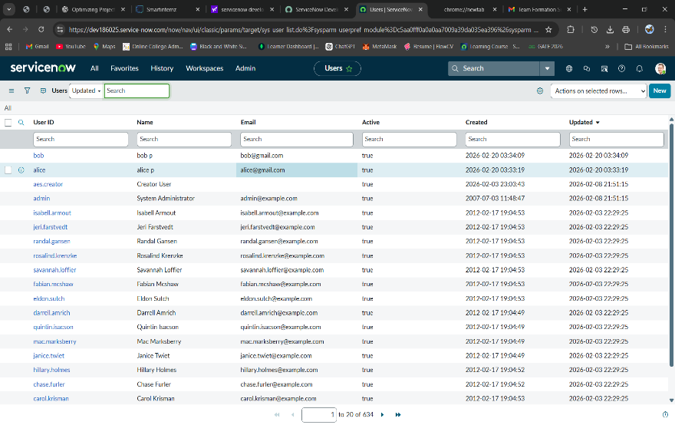
2 | Response  Time | Avg form load time: 300–500 ms  Avg access request submission time: 400–600 ms  Avg approval workflow trigger time: < 1 second | 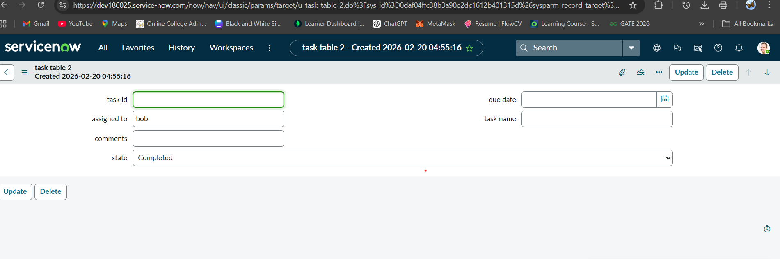
3 | Load Test  Result | Tested with multiple users submitting access requests simultaneously. The system handled concurrent role assignments and approval workflows without failures or security breaches. | 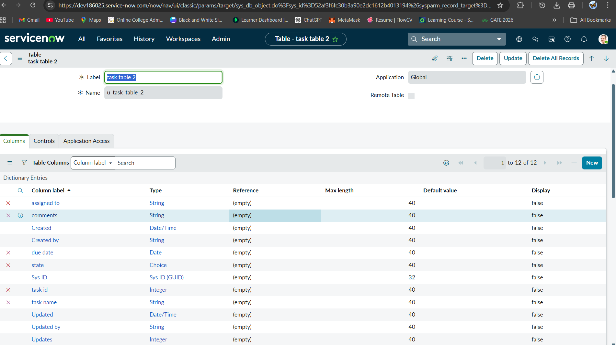

4 | Flow  Performance | flow executed successfully without delay. | 